[Array 19 (2023) 100319](https://doi.org/10.1016/j.array.2023.100319)

|  |  |  |
| --- | --- | --- |
|  | Contents lists available at [ScienceDirect](https://www.elsevier.com/locate/array) |  |
| Array |
| journal homepage: [www.elsevier.com/locate/array](http://www.elsevier.com/locate/array) |
|  | | |

SSFuzzyART: A Semi-Supervised Fuzzy ART through seeding initialization and a clustered data generation algorithm to deeply study clustering solutions

Siwar Jendoubi∗, Aurélien Baelde, Thong Tran

*UPSKILLS R&D, 16 Rue Marc Sangnier 94600, Choisy-Le-Roi, France*1

|  |  |  |
| --- | --- | --- |
| A R T I C L E | I N F O | A B S T R A C T |
| *Keywords:*  Semi-supervised learning  FuzzyART  Initialization by seeding  Clustering  SSFuzzyART  Clustered binary data generation | | Semi-supervised clustering is a machine learning technique that was introduced to boost clustering performance when labeled data is available. Indeed, some labeled data are usually available in real use cases, and can be used to initialize the clustering process to guide it and to make it more efficient. Fuzzy ART is a clustering technique that is proved to be efficient in several real cases, but as an unsupervised algorithm, it cannot use available labeled data. This paper introduces a semi-supervised variant of the FuzzyART clustering algorithm (SSFuzzyART). The proposed solution uses the available labeled data to initialize clusters centers. In another hand, to deeply evaluate the characteristics of the proposed algorithm, a clustered binary data generation algorithm with controlled partitioning is also introduced in this paper. Indeed, the controlled generated clusters allows studying the characteristics of the proposed SSFuzzyART. Furthermore, a set of experiments is carried out on some available benchmarks. SSFuzzyART demonstrated better clustering prediction results than its classic counterpart. |

**1. Introduction**

Clustering techniques are useful to group similar unlabeled data instances together. It is used to explore unlabeled datasets and to discover similarity relationships between its instances. In some real cases, it is possible to have access to labeled data instances. These instances are, usually, not enough to learn a classifier. In fact, the available labels could represent a subset of possible labels, on only a tiny fraction of the dataset, preventing the training of a learner. However, usual clustering algorithms are not designed to consider this information about labels. In such cases, semi-supervised techniques can use the labeled instances to guide the clustering process.

Fuzzy Adaptive Resonance Theory (Fuzzy ART) is a classic cluster-ing algorithm. It was introduced by Carpenter et al. [1]. Fuzzy ART is an unsupervised learning algorithm that incorporates the min operator from the fuzzy set theory into an ART based neural network. This algorithm can learn stable clusters from continuous input patterns. Besides, it is effective for large scaled data, and it runs fast compared to other clustering algorithms [2,3]. These characteristics make Fuzzy ART able to detect clusters with different sizes. Then, small clusters, having few instances, could be detected and separated from larger clusters.

Fuzzy ART is a clustering algorithm that demonstrated good per-formance in many real cases [2,4,5]. However, in the case where some labeled data instances are available, Fuzzy ART cannot con-sider this information to improve the clustering quality. This paper presents a simple and efficient solution to initialize Fuzzy ART with available labeled data instances. Indeed, the proposed approach is a semi-supervised Fuzzy ART (SSFuzzyART) that considers available labeled data instances to initialize clusters.

Binary data is data composed of vectors of arbitrary size whose categories are drawn in a two-valued distribution only. With modalities 0 or 1, a vector of binary data can be 010111001010. They are used in various fields of application and to model several types of data or phenomena. For example, a text document can be modeled by a binary vector representing the presence or absence of terms or characters. In addition, several automatic learning techniques have been introduced for the exploitation of this particular data, [6–9]. In this article, we consider the binary controlled clustered data to deeply study the char-acteristics of the proposed SSFuzzyART algorithm. For that purpose, we need to be able to manage the data characteristics and clusters separability to evaluate the SSFuzzyART algorithm. Binary clustered data is adaptable for such cases. In fact, binary data has only two

∗ Corresponding au[thor.](mailto:siwar.jendoubi@upskills.ai)

*[E-mail addresses:](http://www.upskills.com)* [siwar.j](http://www.upskills.com)[endoubi@upskills.ai](mailto:siwar.jendoubi@upskills.ai) (S. Jendoubi), [thong.tran@upskills.ai](mailto:thong.tran@upskills.ai) (T. Tran).

1 <http://www.upskills.com>

<https://doi.org/10.1016/j.array.2023.100319>  
[Received 14 March 2023; Received in revise](https://doi.org/10.1016/j.array.2023.100319)d form 30 August 2023; Accepted 6 September 2023   
Available online 9 September 2023   
[2590-0056](http://creativecommons.org/licenses/by-nc-nd/4.0/)/© 2023 The Author(s). Published by Elsevier Inc. This is an open access article under the CC BY-NC-ND license (<http://creativecommons.org/licenses/by-nc-nd/4.0/>).

*S. Jendoubi et al.*  *Array 19 (2023) 100319*

modalities, which make it easier to manage and generated clusters are better controlled.

In this article, an algorithm for generating binary data grouped by clusters of controlled variances is introduced. This algorithm allows the generation of binary data sets having characteristics known and mastered beforehand. These datasets are used to test and validate the effectiveness of binary data partitioning solutions. Being able to control the characteristics of the data generated also makes it possible to study the applicability of these methods and their weaknesses. These char-acteristics are also useful for choosing a machine learning technique. Indeed, the choice will be guided by the characteristics of the data and tests in circumstances similar to real cases. In addition, a study comparing dimension reduction algorithms was carried out to show the usefulness of the generated data in the choice of a dimension reduction algorithm, under the angle of the conservation of the characteristics of the clusters in space.

The contributions of this paper are the following: (1) the proposition of a semi-supervised version of the Fuzzy ART, SSFuzzyART, clustering algorithm. SSFuzzyART uses a set of available labeled instances to initialize the clusters centers. Also, a set of experiments is made to eval-uate the proposed algorithm and to study its strength and weakness. (2) the proposition of a data generation algorithm and the study of the characteristics of the generated data and the use of the generated data to deeply study SSFuzzyART algorithm characteristics.

This paper is organized as follows: Section 2 presents an overview of the current state of the art on the semi-supervised clustering, Fuzzy ART and clustering data generation. Section 3 details the classic Fuzzy ART algorithm and the proposed SSFuzzyART. Section 4 presents the clustered binary data generation algorithm, and evaluates the gener-ated clusters through a set of experiments. Section 5 introduces the considered evaluation measures, evaluates the characteristics of SS-FuzzyART using the generated data, compares SSFuzzyART clustering to FuzzyART clustering and discusses the experiment results. Finally, Section 6 concludes the paper.

**2. Related works**

*2.1. Semi-supervised clustering*

Semi-supervised clustering combines elements of both semi-super vised learning and clustering analysis. By incorporating class labels, semi-supervised clustering directs the clustering procedure, leading to improve performance. Over the past years, many remarkable initiatives have surfaced, focusing on both exploration and practical implementa-tion in various fields. [10].

Adaptive Resonance Theory (ART) and Semi-supervised learning has attracted several researchers’ attention. Kim et al. [11] introduced a label propagation ART algorithm. It is a semi-supervised approach. Another semi-supervised Message Passing Adaptive Resonance The-ory (MPART), [12], was also introduced. Recently, [13] proposed HANFA-ART with ACA which is a Hybrid Adaptive Neural-Fuzzy Al-gorithm based on Adaptive Resonant Theory with Adaptive clustering Algorithm. This model has nine major components, and the Adaptive Resonant Theory is one of them. Another interesting clustering solution was recently introduced by Masuyama et al. [14]. This work proposes a solution for better estimating the specification of a similarity threshold (vigilance parameter) which is an interesting parameter on which the prediction of the ART based models is highly dependent.

Fuzzy Adaptive Resonance Theory algorithm is a classic online clustering algorithm that is known to be sensitive to data order. To remedy this issue, several research papers introduced solutions for this problem. Elnabarawy et al. [15] used evolutionary computation to improve Fuzzy ART. Liew et al. [4] used a genetic algorithm for the same purpose.

Clusters initialization by seeding and semi-supervised clustering are usual machine learning techniques that are always used to make the

2

*S. Jendoubi et al.*  *Array 19 (2023) 100319*

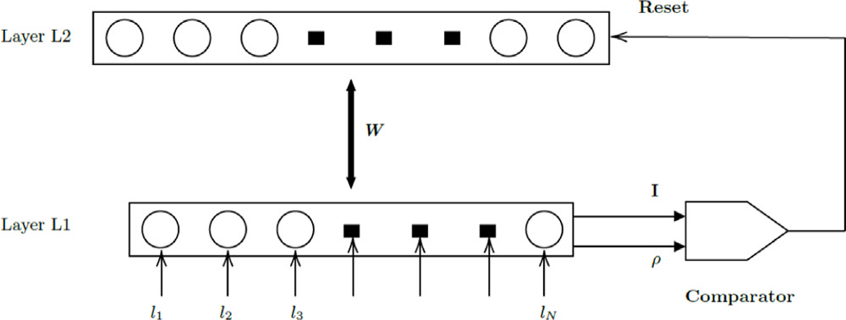

**Fig. 1.** Fuzzy ART architecture.

data used did not allow significant experimentation in terms of data partitioning. Indeed, the binary data generation method used only allowed the generation of high-dimensional data, but these data do not present detectable clusters. Thus, these datasets only allowed the study of the scalability of the proposed clustering algorithm.

To the best of our knowledge, the literature does not present a clustered data generation solution that could be useful to analyze all the characteristics of the proposed SSFuzzyART algorithm or that allows to generate similar clustered binary data to the generated data using the proposed algorithm. Our need for clustered binary data with the possibility to manage the intra and inter clusters distances and the data sparsity motivated us to introduce the data generation algorithm proposed in Section 4

**3. Semi-supervised Fuzzy ART (SSFuzzyART)**

In real world problems, some labeled data instances may be avail-able. Fuzzy ART algorithm is not able to consider this available data in its clustering process. To resolve this problem and make Fuzzy ART output more efficient in such cases, this paper introduces the SSFuzzyART algorithm.

This section details first the Fuzzy ART algorithm. Next, it intro-duces the SSFuzzyART.

*3.1. Fuzzy ART algorithm*

Fuzzy ART [1] is a classic clustering algorithm that extends the ART1 algorithm. Indeed, ART1 algorithm categorizes only binary in-put instances. Then, Fuzzy ART extends this algorithm to categorize both binary and analog instances. For each input instance, the Fuzzy ART network looks for the ‘‘nearest’’ cluster that ‘‘resonates’’ with that instance. Next, it updates the center of the selected cluster with the input instance. The vigilance parameter, *𝜌* ∈ [0*,* 1], is an input parameter of Fuzzy ART that determines the similarity of instances in the same cluster. When the vigilance parameter increases, the similarity of instances in the same cluster grows, which leads to a larger number of clusters, [27].

Fuzzy ART network is composed of two layers *𝐿*1 and *𝐿*2. Fig. 1 shows the architecture of Fuzzy ART network. The layer *𝐿*1 is the input presentation layer. It has as many neurons as the number of features in the input instance. The layer *𝐿*2 is the category representation layer. Then, neurons in the *𝐿*2 layer are added while the learning progresses. Indeed, for each new detected category, a new neuron is appended to the *𝐿*2 layer. Besides, the layer *𝐿*2 maintains one additional neuron in the uncommitted state. The uncommitted neuron is useful to maintain the vigilance criterion (equation (3)) satisfied when a new category arises [28].

When a new data instance, *𝐼*, is presented in the layer *𝐿*1, each neuron in the layer *𝐿*2 computes a score for the category choice, using the following equation:

|  |  |  |
| --- | --- | --- |
| *𝑇𝑗* = | ~~|~~*𝐼* ∧ *𝑤𝑗*~~|~~ | (1) |

3

*S. Jendoubi et al.*  *Array 19 (2023) 100319*

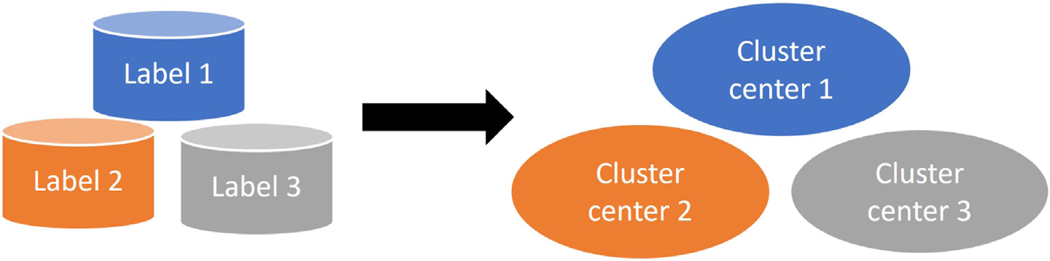

**Fig. 2.** SSFuzzyART initialization.

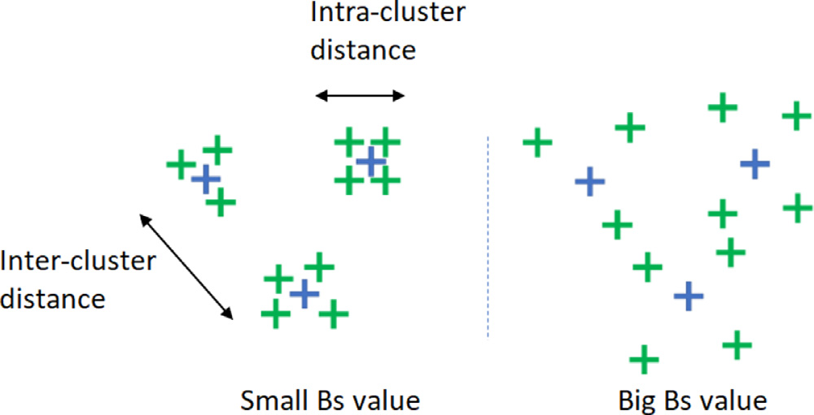

**Fig. 3.** An explanatory example of intra and inter-cluster distances and the impact of *𝐵𝑠* on the generated clusters.

|  |  |
| --- | --- |
| **Table 1**  Category weights computation example through ap-plying the Fuzzy min operator on four instances of a given label, the self-learning rate *𝛽* = 1 in this example. | |
| Instance 1  Instance 2  Instance 3  Instance 4  **Category weights** | 000111  101011  010111  100011  **000011** |

3. In the third scenario, the labeled data is used to initialize cate-gory neurons (layer *𝐿*2). Next, initialization instances are clus-tered with the rest of the data, but their labels are set and cannot change during the clustering process, thus guiding the clustering process.

The choice of the scenario depends on the data to be clustered and the problem to be solved. For example, if there is some doubt about the labeled instances, it could be useful to apply the second scenario and to keep SSFuzzyART cluster these instances again. In cases where the quality of labeled instances is high, then it is recommended to consider the first or the third scenario.

In this paper, **the second scenario** is considered. Then, labels are no longer considered in the clustering process and the instances used for initialization are clustered with the rest of the data regardless of their initial labels. This choice allows studying the ability of SSFuzzyART to correctly put the labeled instances in their clusters.

**4. Clustered binary data generation with controlled partitioning**

This section present and explain the proposed data generation algo-rithm for binary clustered data. Besides, we present an empirical study of the generated clusters’ separability.

*4.1. Data generation algorithm*

This section introduces the data generation algorithm and the pa-rameters that allow controlling the characteristics of generated clusters. Algorithm 1 details the proposed data generation algorithm. The values

4

*S. Jendoubi et al.*  *Array 19 (2023) 100319*

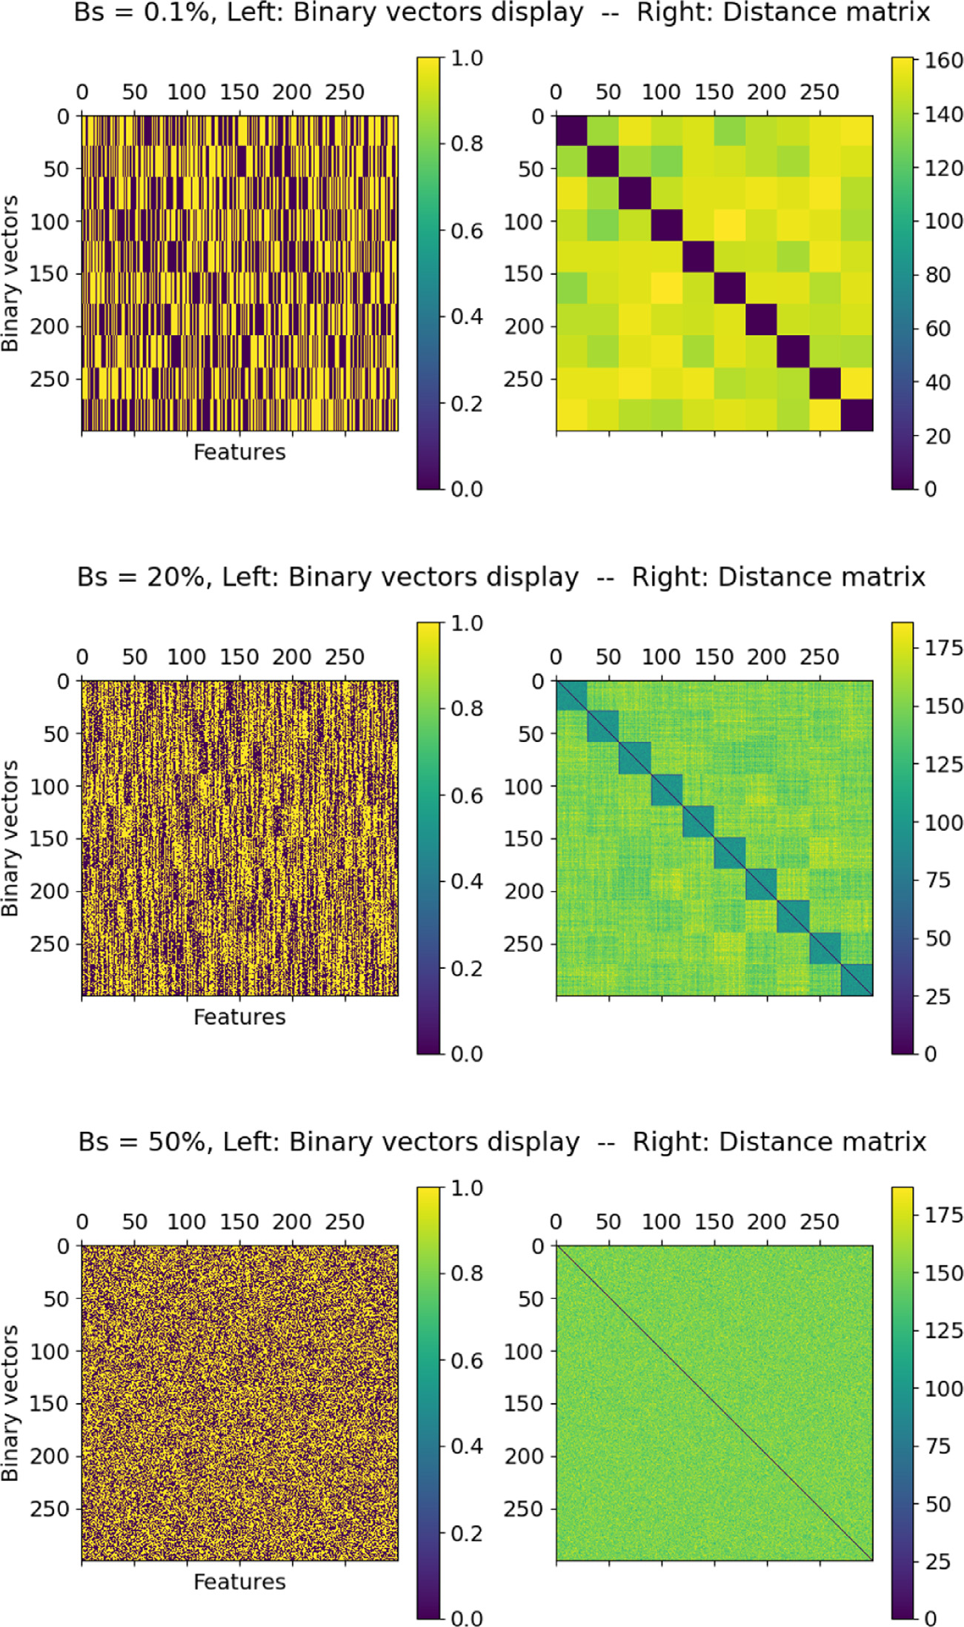

**Fig. 4.** Display of the generated binary vectors and their corresponding distance matrices for three values of *𝐵𝑠*: 0.1%, 20% and 50% respectively. Number of clusters *𝐶* = 10,

Dimension *𝐷* = 300 and *𝑁𝑐* = 30. The Manhattan distance is used.

The binary data generation algorithm is, also, compared to a com-monly used solution in the literature that is considered in this paper as a baseline solution. This solution consist of generating real-valued ran-dom clustered data and then binarizing the generated clusters against a threshold. For this purpose, we used the available function make_blobs2

2 [make_blobslink](https://shorturl.at/lMN12)

5

*S. Jendoubi et al.*  *Array 19 (2023) 100319*

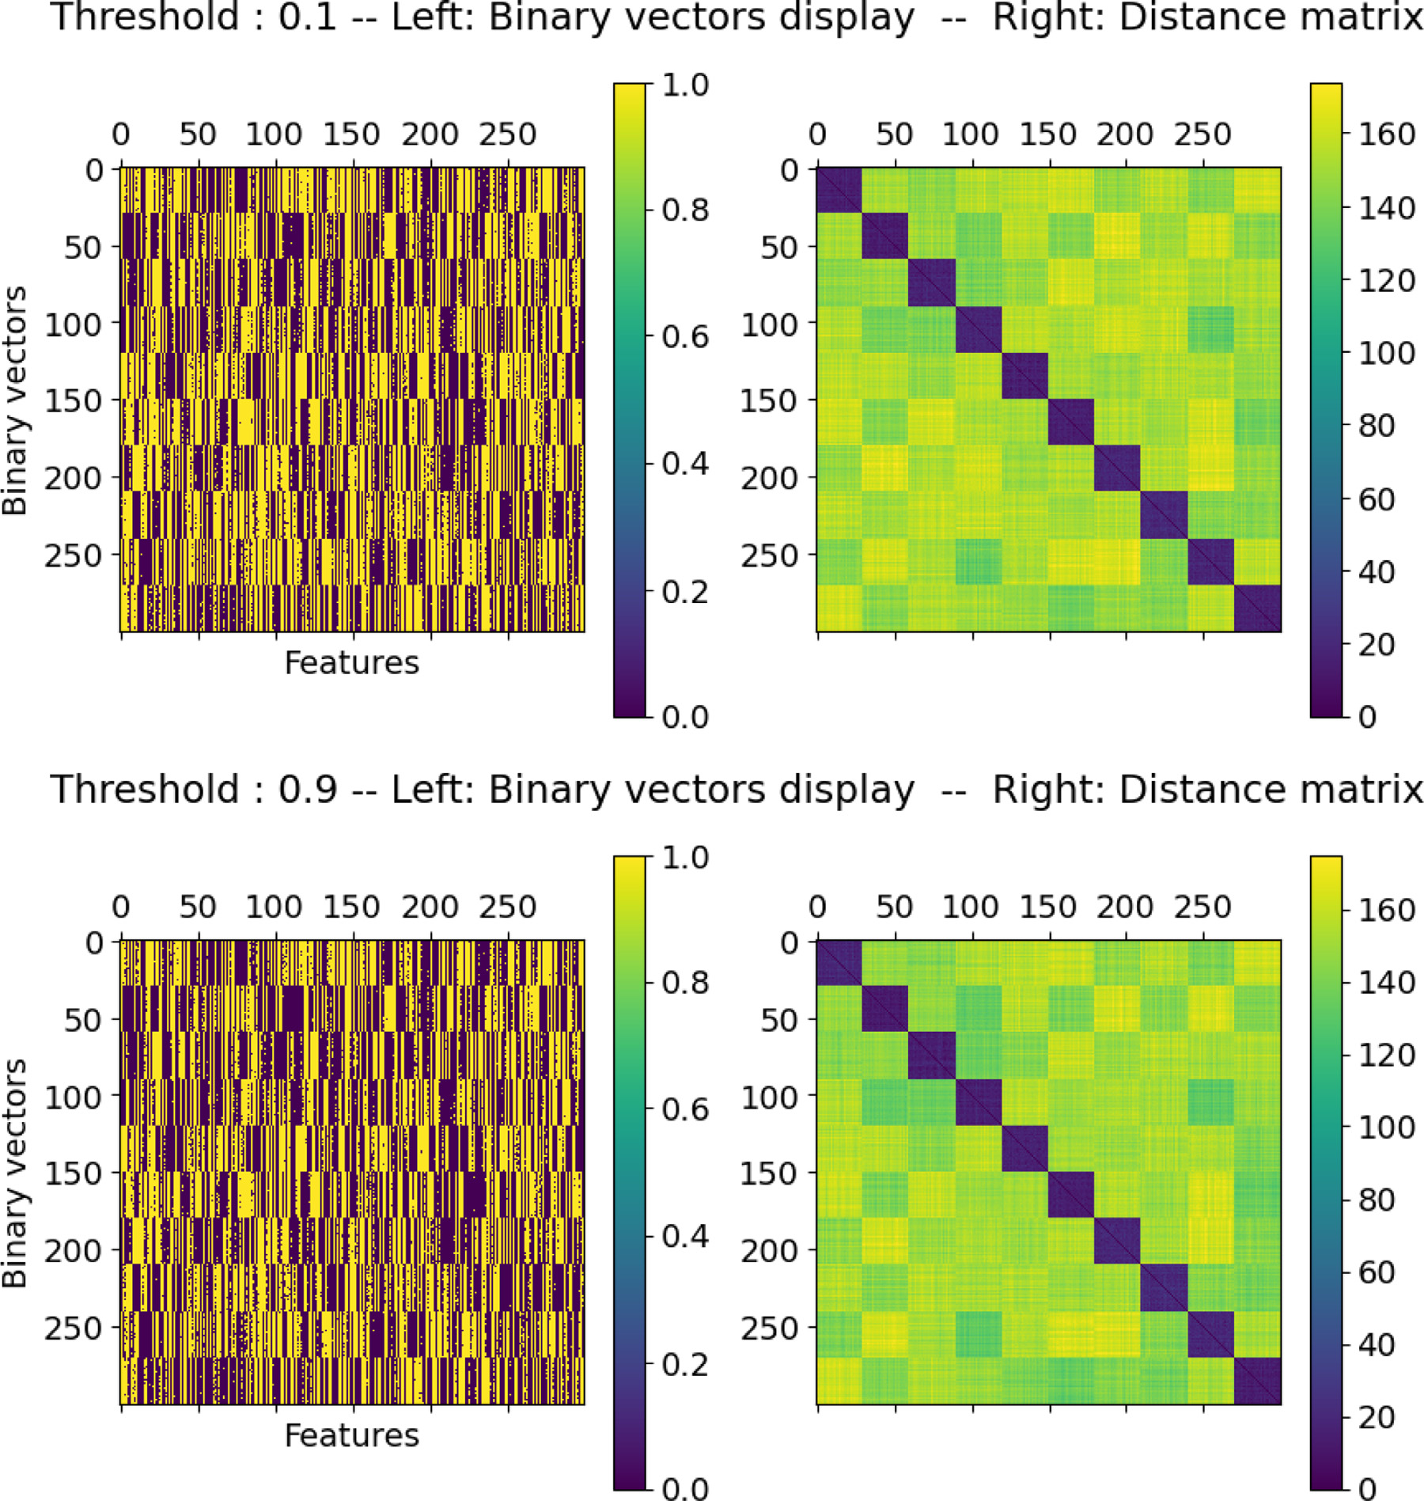

**Fig. 5.** Display of the generated binary vectors using the Baseline data generation algorithm and their corresponding distance matrices for two values of threshold: 0.1 and 0.9

respectively. Number of clusters *𝐶* = 10, Dimension *𝐷* = 300 and *𝑁𝑐* = 30. The Manhattan distance is used.

Fig. 4 shows a visualization of three data sets and corresponding distance matrices with three-bit swapping rates *𝐵𝑠* = 0*.*1%, *𝐵𝑠* = 20% and, *𝐵𝑠* = 50% respectively. Besides, Fig. 5 shows a visualization of two data sets generated with the Baseline data generation algorithm. In this experiment, we generated one real valued data set as explained above, and we used two different binarization threshold values, 0.1 and 0.9 respectively. The distance matrix consists of calculating the distance between each pair of vectors (*𝑥, 𝑦*). The distance used in this paper is the Manhattan distance:

*𝑀𝑎𝑛*(*𝑥, 𝑦*) =∑*𝑥𝑖* − *𝑦𝑖*  (5)

The vectors in Fig. 4 have a dimension *𝐷* = 300. Besides, 10 clusters containing 30 vectors each are generated. When the bit-swapping rate is low (*𝐵𝑠* = 0*.*1%), the clusters are easily visible and separable. In coher-ence, the distance matrix shows that the data vectors belonging to the same clusters are close to each other. If the bit swapping rate increases

6

*S. Jendoubi et al.*  *Array 19 (2023) 100319*

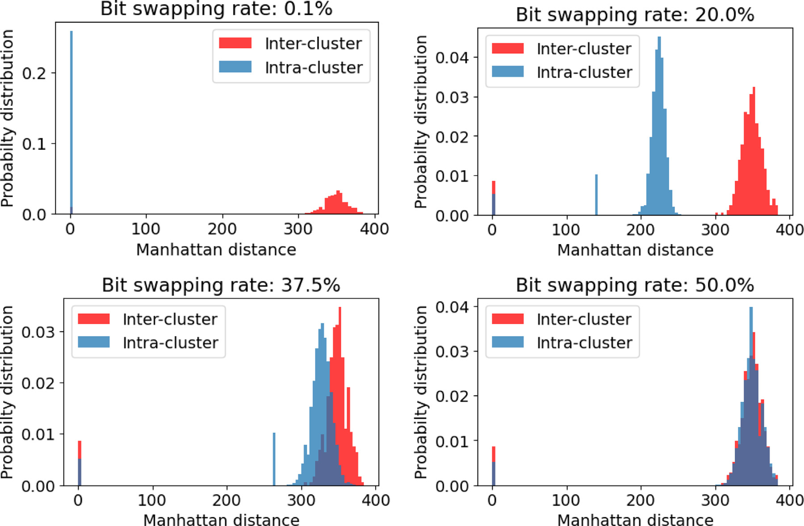

**Fig. 6.** Intra- and inter-cluster distance distributions Evolution in the function of bit swapping rate. *𝐶* = 30, *𝐷* = 700, and *𝑁𝑐* = 50. The distance Manhattan is used.

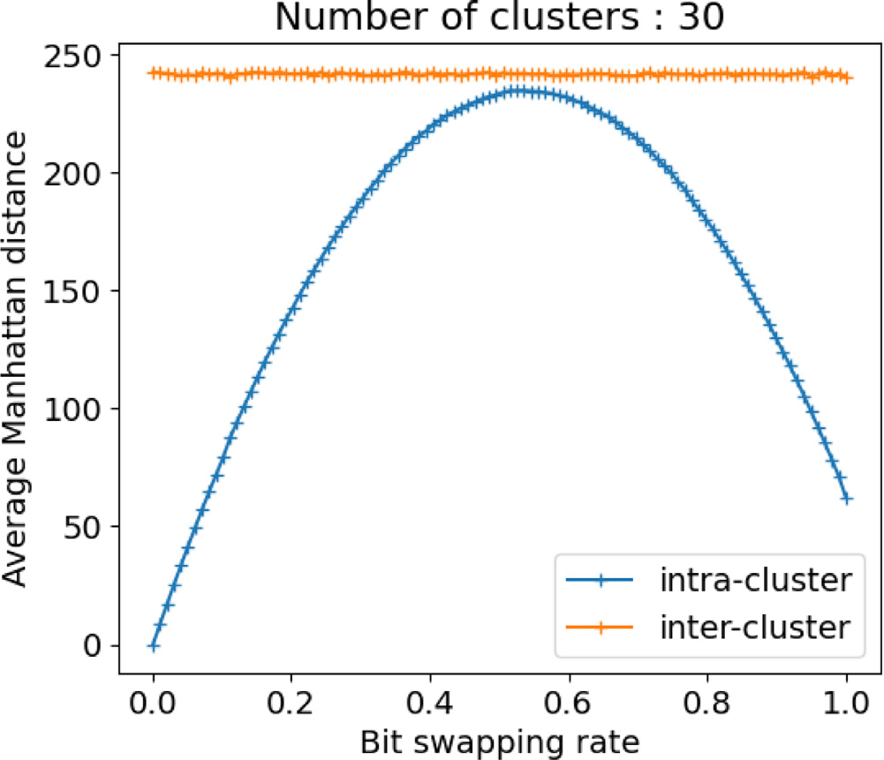

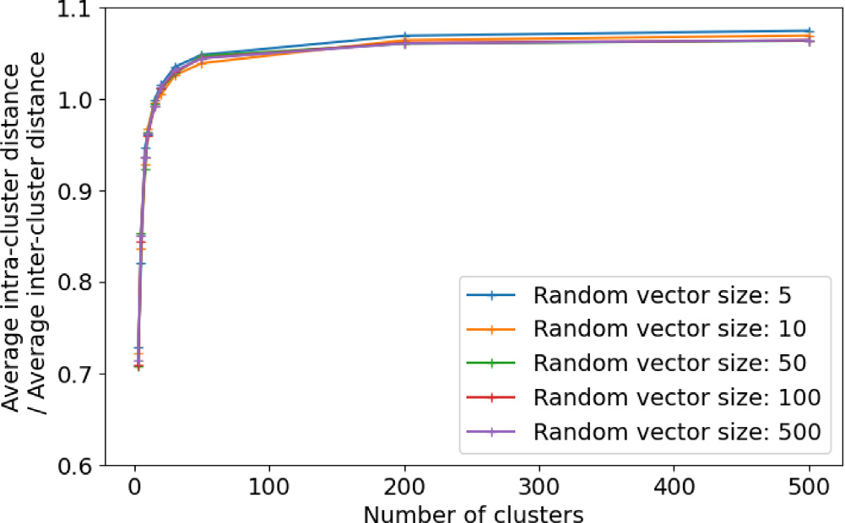

**Fig. 8.** Ratio between the average value of the inter-cluster distance and the maximum of the intra-cluster distance (several values of *𝐵𝑠* were used to determine the maximum and the average), according to the number of clusters *𝐶* and the dimension of the vector *𝐷*. The Manhattan distance is used.

|  |  |  |
| --- | --- | --- |
| **Fig. 7.** Evolution of the intra and inter-cluster average distance according to the rate of bit swapping. Number of clusters *𝐶* = 30, number of vectors per cluster *𝑁𝑐* = 15 and dimension of the binary vector = 500. The Manhattan distance used. | is expressed as follows:  *𝐷𝑖𝑛𝑡𝑒𝑟*(*𝑥, 𝑦*) = *𝑀𝑎𝑛*(*𝑥, 𝑦*) ∣ ∀*𝐶𝑖, 𝐶𝑗* ∈ *𝐶, 𝐶𝑖* ≠ *𝐶𝑗, 𝑥* ∈ *𝐶𝑖 𝑒𝑡 𝑦* ∈ *𝐶𝑗* | (7) |

The experiment illustrated by Fig. 6 confirms these observations. This experiment consists in plotting the histograms of the intra- and inter-cluster distances as a function of the average bit-swapping rate. An intra-cluster distance is a distance between two vectors belonging to the same cluster *𝐶𝑖*, defined as follows:

(6) *𝐷𝑖𝑛𝑡𝑟𝑎*(*𝑥, 𝑦*) = *𝑀𝑎𝑛*(*𝑥, 𝑦*) | ∀*𝐶𝑖* ∈ *𝐶, 𝑥, 𝑦* ∈ *𝐶𝑖* Conversely, inter-cluster distances relate to vectors belonging to different clusters. Let *𝐶𝑖* and *𝐶𝑗* be two different clusters, this distance

7

*S. Jendoubi et al.*  *Array 19 (2023) 100319*

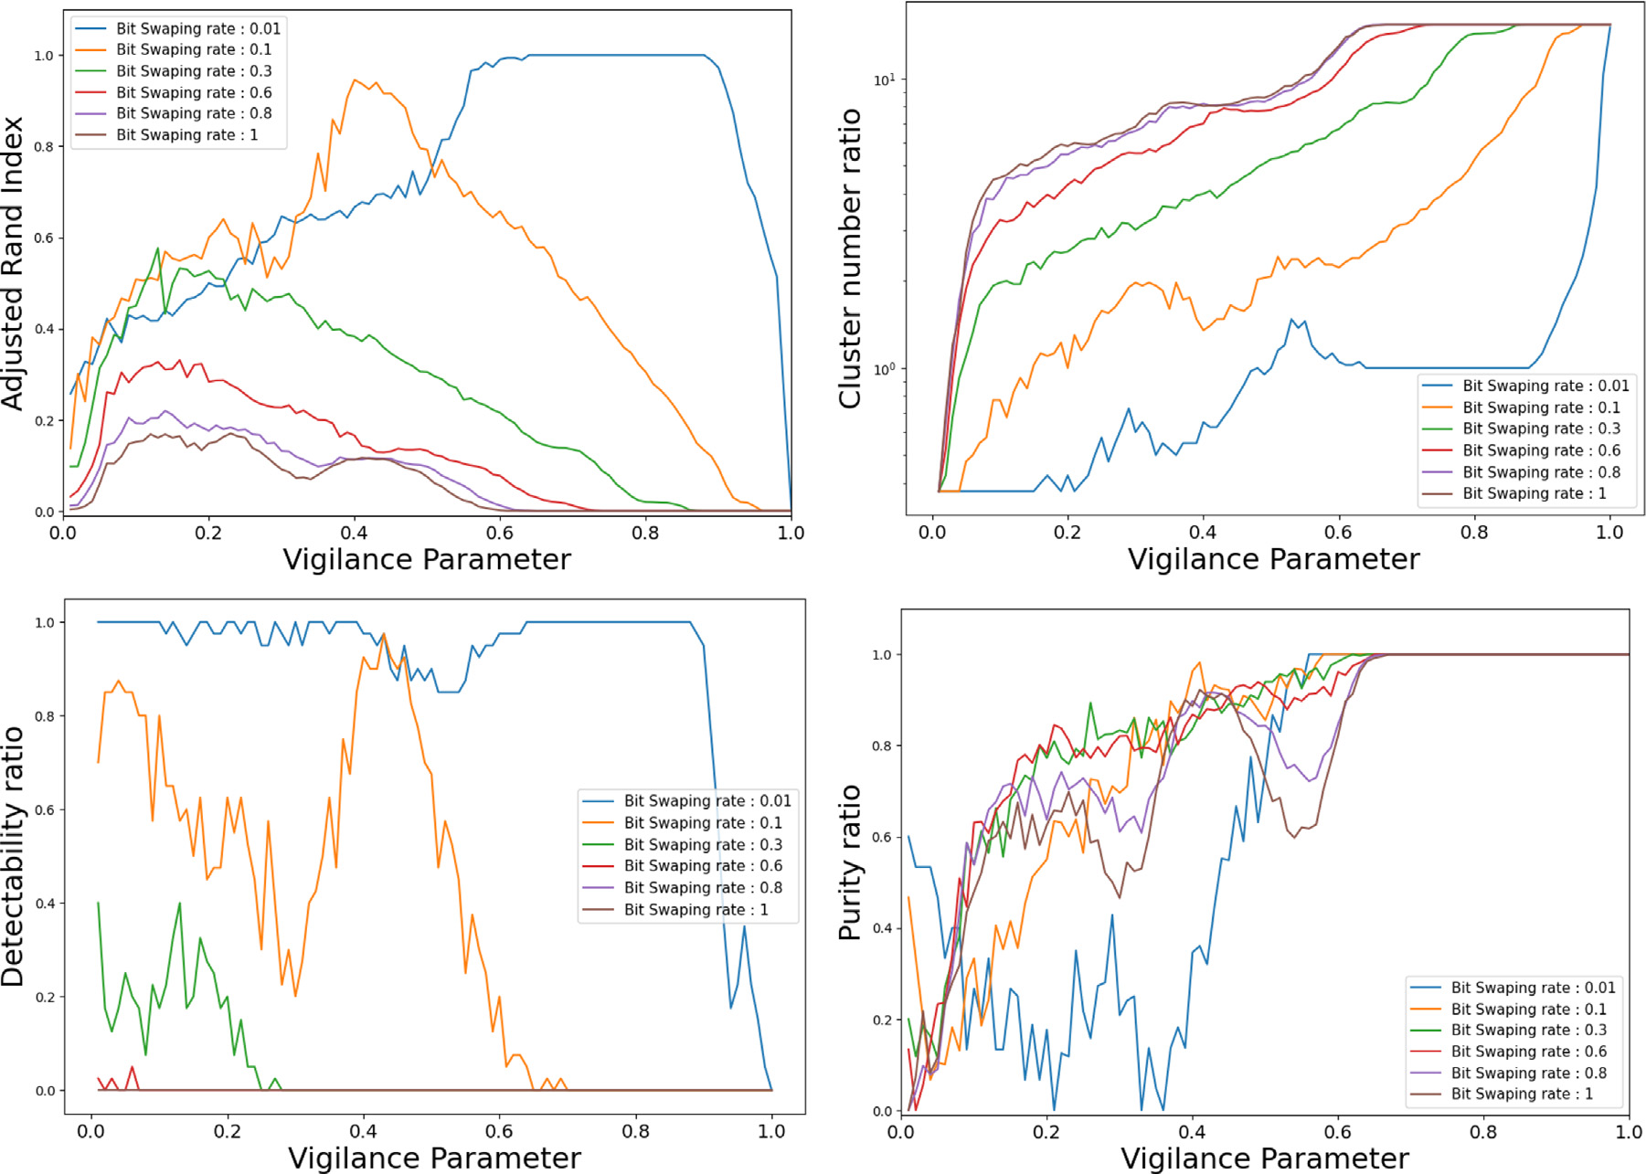

**Fig. 9.** SSFuzzyART clustering quality (compared to ground truth) versus the vigilance parameter for several bit-swapping rates.

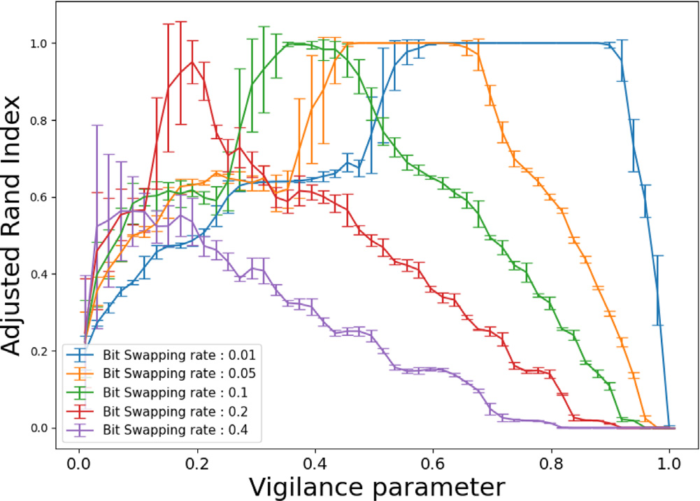

**Fig. 10.** Adjusted Rand Index versus the vigilance parameter for several values of bit swapping rate and binary vector feature number.

|  |
| --- |
| in coherence with the definition of the algorithm, are independent of the rate *𝐵𝑠*.  To better understand the impact of *𝐵𝑠* on intra- and inter-cluster dis-tances, we introduce the notions of average distances by the following definitions:  *𝐷𝑖𝑛𝑡𝑟𝑎* =  *𝐷𝑖𝑛𝑡𝑒𝑟* = *𝑁𝑐𝑜𝑢𝑝𝑙𝑒𝑠 𝑖𝑛𝑡𝑒𝑟*  *𝑁𝑐𝑜𝑢𝑝𝑙𝑒𝑠 𝑖𝑛𝑡𝑟𝑎*  1  1  *𝑥,𝑦*∈*𝐸*  *𝑥,𝑦*∈*𝐸*∑∑  *𝐷𝑖𝑛𝑡𝑒𝑟*(*𝑥, 𝑦*)  *𝐷𝑖𝑛𝑡𝑟𝑎*(*𝑥, 𝑦*) (8)  (9)  These average distances correspond to the arithmetic mean of the histograms presented in Fig. 6. |

8

*S. Jendoubi et al.*  *Array 19 (2023) 100319*

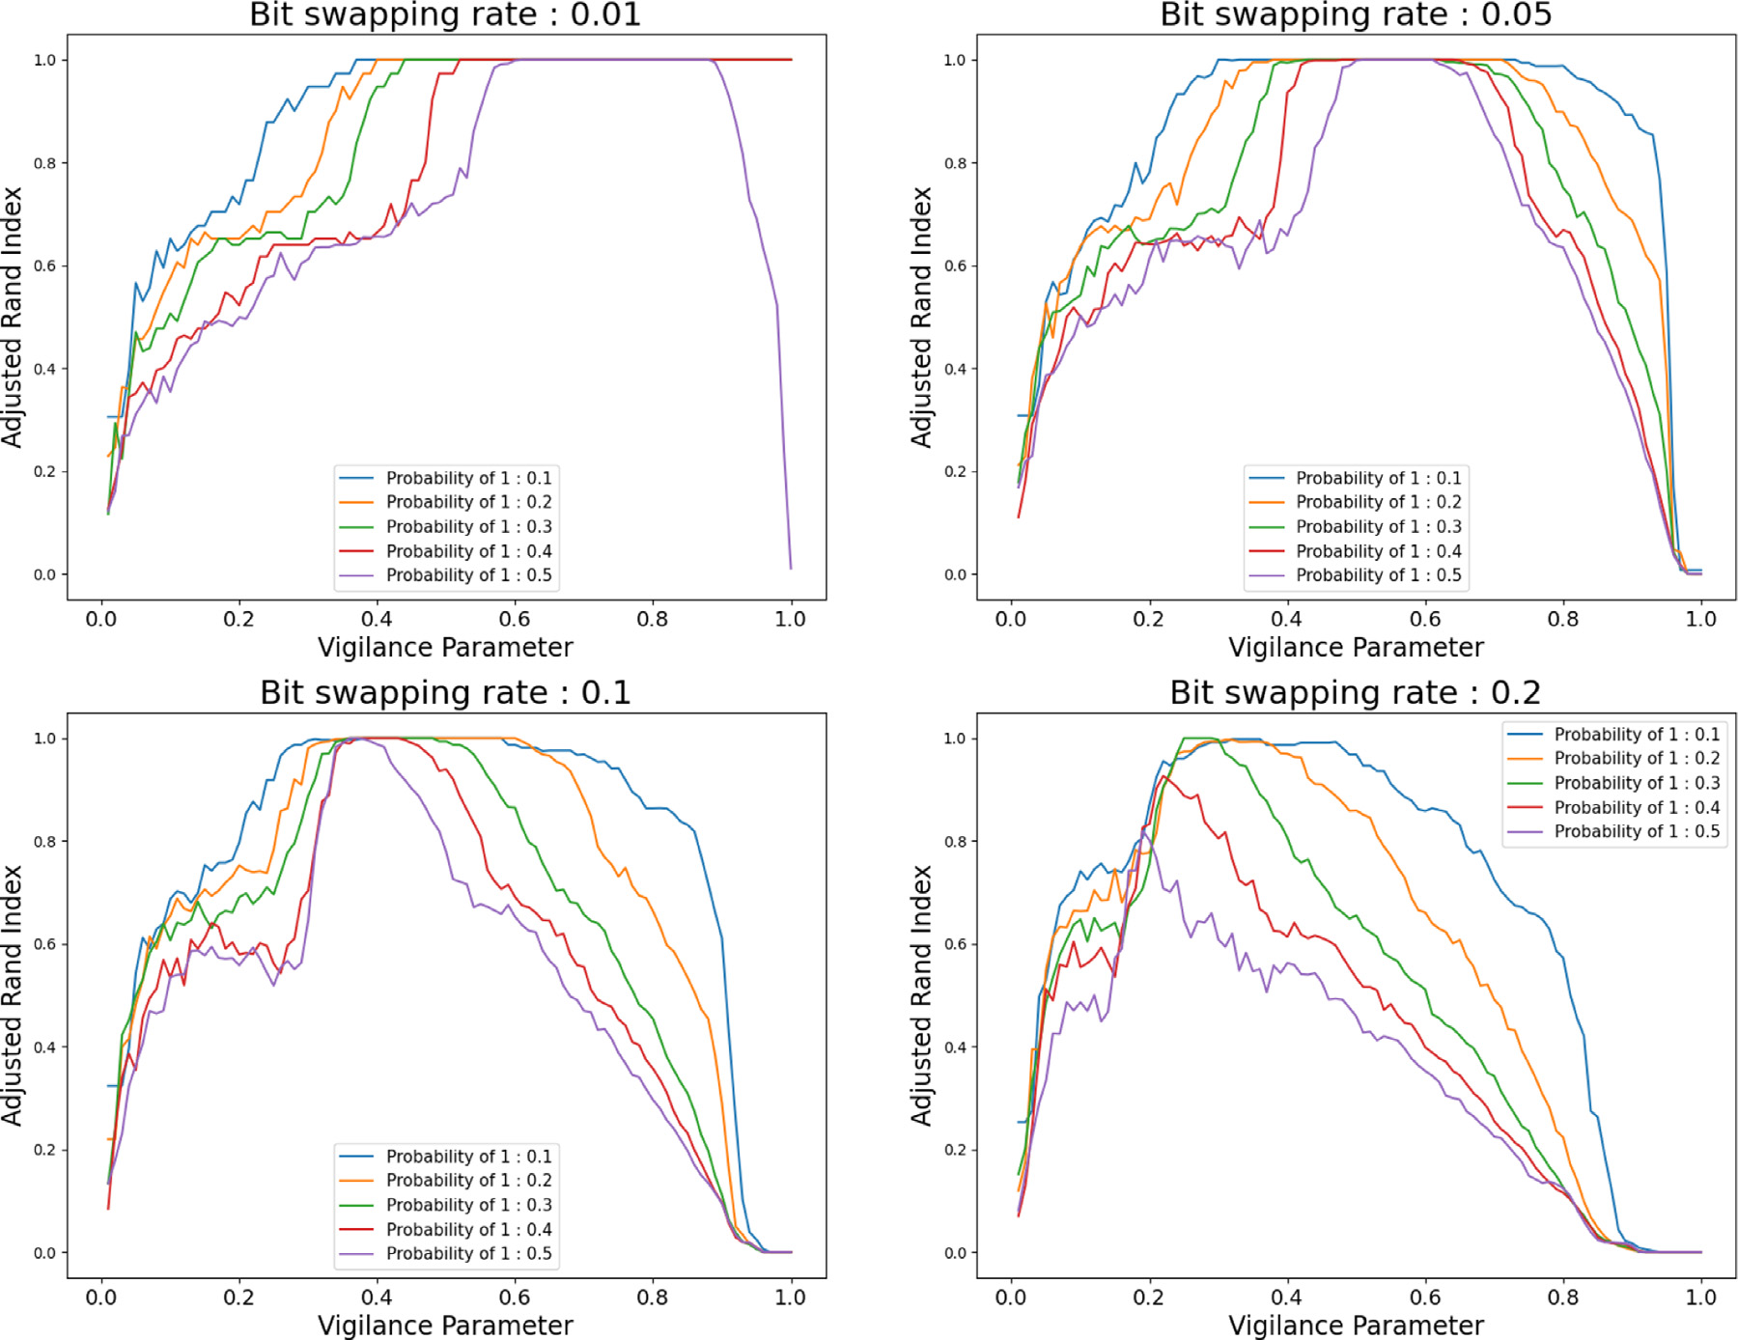

**Fig. 12.** Adjusted Rand Index for several bit swapping rates, for several occurrence probabilities of 1 in binary vectors.

no more clusters defined. The value of the maximum at *𝐵𝑠* = 50% is linked to the arbitrary choice of the expectation of Bernoulli’s law at 0.5 used for the generation of the prototypes. As *𝐵𝑠* continues to increase, the inter-cluster distance decreases because the bit-swap potential has been exceeded, and any further bit change leads to the complementary vector of the initial vector. In the case where *𝐵𝑠* = 100%, all the vectors are equal to the complement of the prototype, except the prototype itself, hence the fact that the intra-cluster distance is not strictly zero. Next, Fig. 8 illustrates the impact of the number of clusters *𝐶* and the dimension of the vectors *𝐷* on the intra- and inter-cluster distances. This figure presents the ratio between the average value of the inter-cluster distance and the maximum of the average intra-cluster distance, defined as follows:

|  |  |  |
| --- | --- | --- |
| *𝑅* = | *𝐷𝑖𝑛𝑡𝑒𝑟*  *𝑚𝑎𝑥𝑥,𝑦*∈*𝐸 𝐷𝑖𝑛𝑡𝑟𝑎*(*𝑥, 𝑦*) | (10) |
| depending on the number of clusters *𝐶* and the dimension of the vector, *𝐷*.  This figure shows that the vector dimension has no impact on the inter and intra-cluster distances. On the other hand, *𝑅* depends on the number of clusters only if this number is less than 100. When the *𝑅* indicator is less than 1, the clusters disappear for the bit swapping rates *𝐵𝑠* less than 50%. Controlling the clusters concentration is therefore difficult in this case. In the case where the *𝑅* indicator is greater than 1, the clusters disappear from a *𝐵𝑠* equal to 50%. Therefore, the clusters can be controlled independently of the *𝐷* dimension of the vectors. Moreover, the more the number of generated clusters increases, the easier it is to control the concentration of the vectors. | | |

9

*S. Jendoubi et al.*  *Array 19 (2023) 100319*

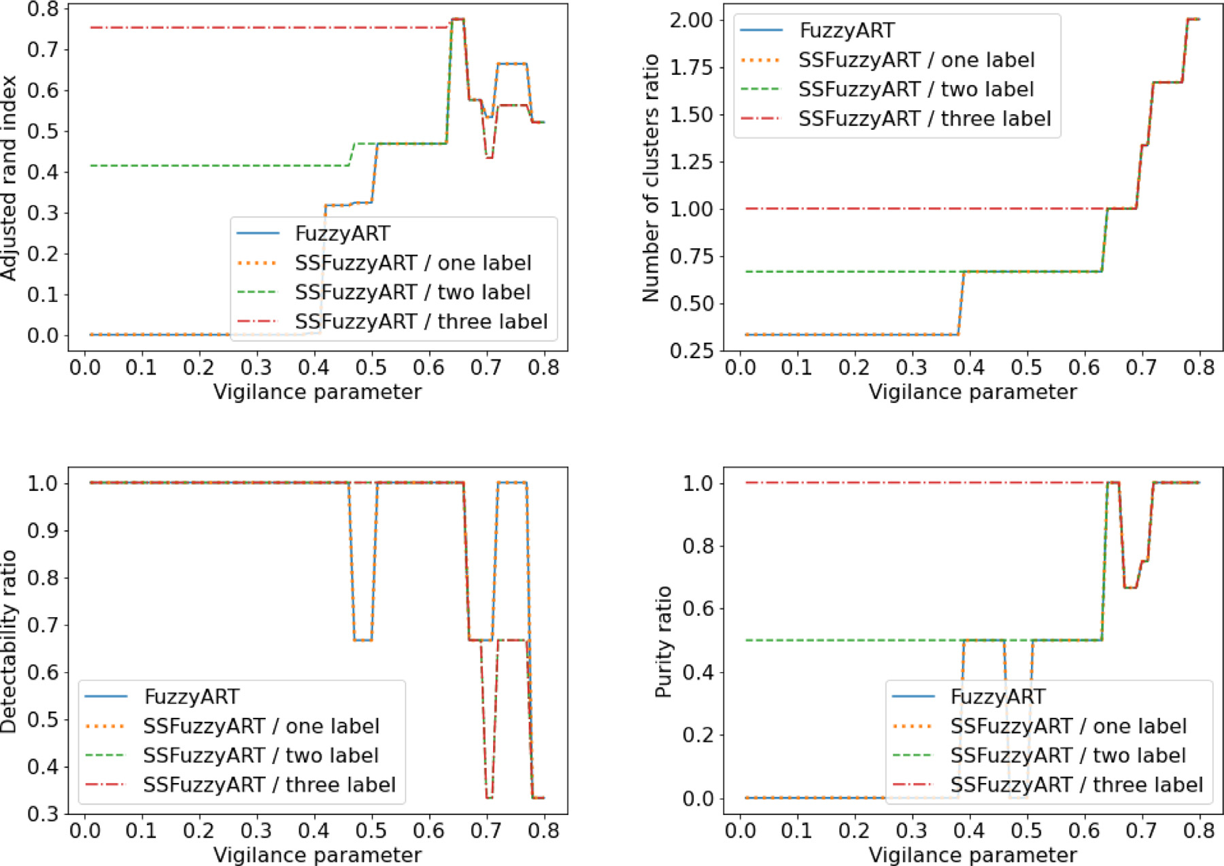

**Fig. 13.** SSFuzzyART VS Fuzzy ART on Iris dataset. In this experiment, three initialization samples were considered. The first one contains 5 instances having the same label. The second one contains 10 instances having two labels (five instances per label). The third one contains 15 instances having three labels (five instances per label).

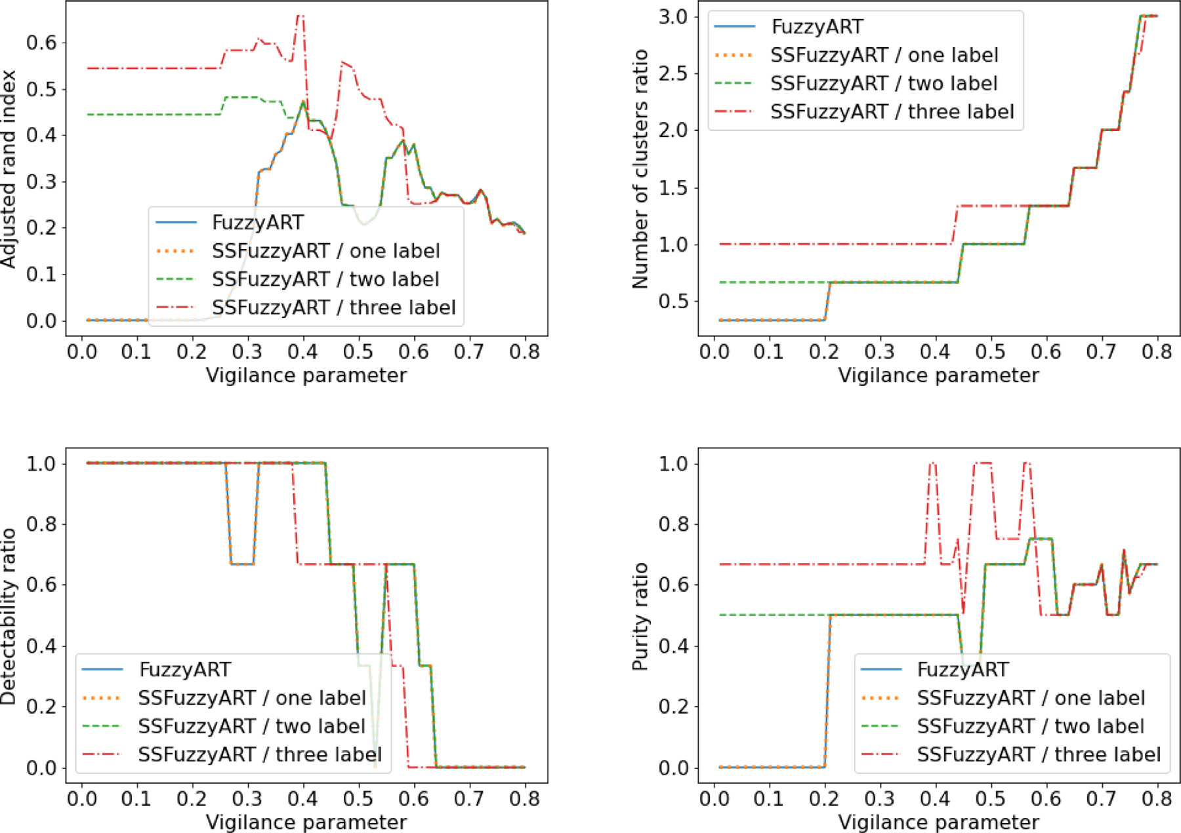

**Fig. 14.** SSFuzzyART VS Fuzzy ART on Wine dataset. In this experiment, three initialization samples were considered. The first one contains 5 instances having the same label. The second one contains 10 instances having two labels (five instances per label). The third one contains 15 instances having three labels (five instances per label).

10

*S. Jendoubi et al.*  *Array 19 (2023) 100319*

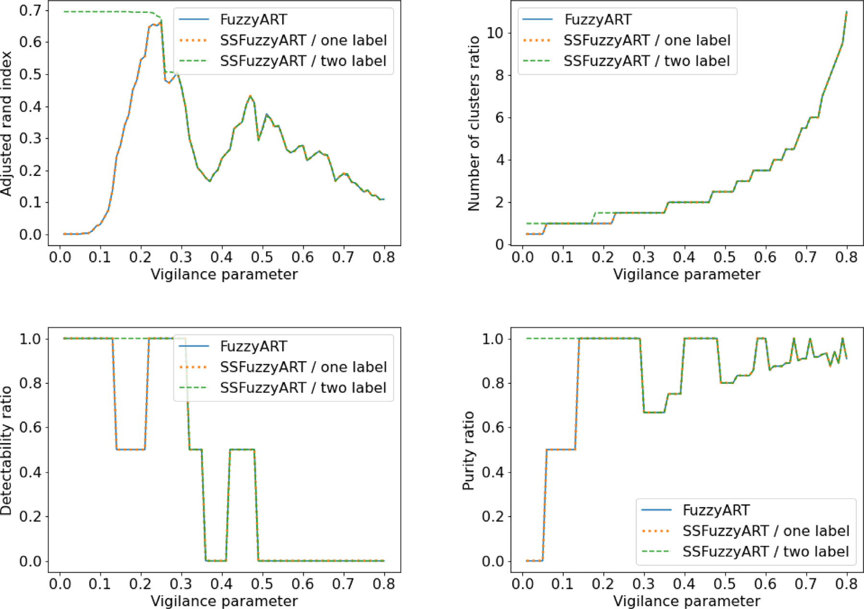

**Fig. 15.** SSFuzzyART VS Fuzzy ART on Breast cancer dataset. In this experiment, two initialization samples were considered. The first one contains 30 instances having the same

label. The second one contains 60 instances having two labels (30 instances per label).

predicted clustering has exactly the same number of clusters as the target clustering. This measure is useful to evaluate Fuzzy ART and SSFuzzyART, as both do not use the number of clusters as input.

• *Cluster purity ratio*: the ratio of pure clusters, where a cluster is considered pure if at least 70% of its elements have the same label.

• *Label detectability ratio*: the ratio of detectable labels, where a label is considered detectable if at least 70% of data instances having that label are in the same cluster.

The considered cluster purity ratio and label detectability ratio have some tolerance on the definition of pure cluster and detectable label, respectively. This tolerance is defined by the fact that a cluster is pure if at least 70% of its elements have the same label, and a label is detectable if at least 70% of data instances having that label are in the same cluster. This tolerance allows these two measures to accept a clustering error of 30%. The choice of the tolerance value is defined according to the clustering problem, then for some problems it could be higher and for other problems it could be lower than 70%. In this paper, the clustering tolerance is fixed to 70%. A good prediction should have high cluster purity ratio and high label detectability ratio. This tolerance is useful to find the best compromise between these two measures. These two measures are influenced by the number of clusters. Consequently, when the number of clusters is high, these clusters are usually pure. However, in that case, the detectability of labels is low. With a high number of clusters, a given label instances could be scattered in several clusters.

The next section presents and discusses experiment results and the impact of the layer *𝐿*2 initialization on the final prediction of the SSFuzzyART.

11

*S. Jendoubi et al.*  *Array 19 (2023) 100319*

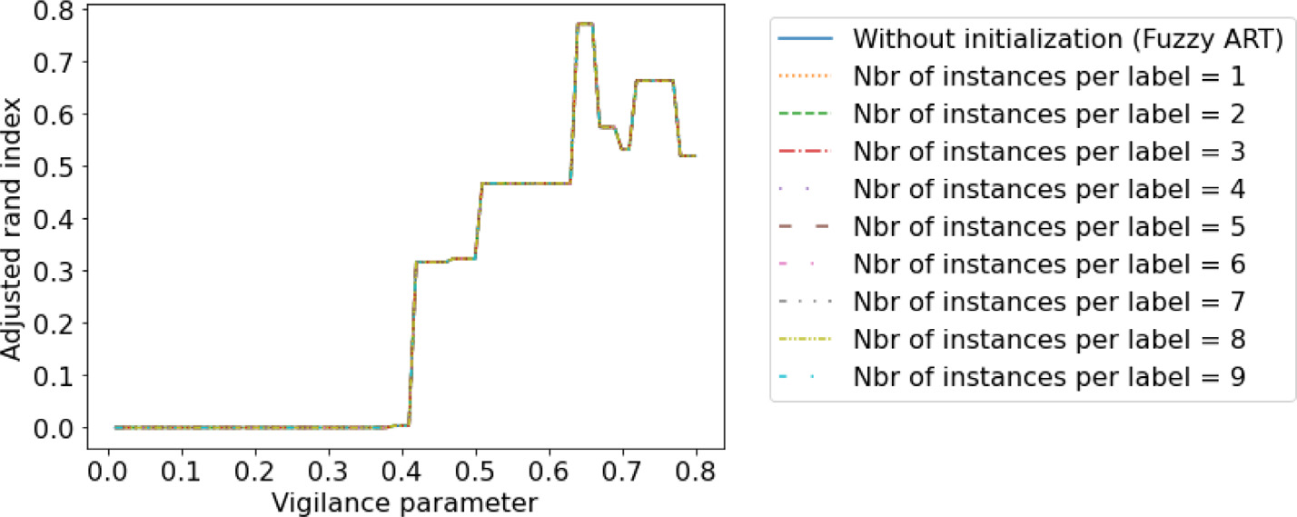

**Fig. 16.** Impact of the number of considered instances per label in the initialization sample of the SSFuzzyART compared to Fuzzy ART (without initialization). Iris dataset is

used, only one label is considered in this experiment.

meaning that clusters are bigger and closer to one another, SSFuzzyART is less able to accurately cluster the data. Moreover, the maximum of the Rand index moves to the left: as the generated cluster is bigger and closer, some begin to merge and the vigilance parameter allows for the maximum Rand index is lower to allow coarse clusters to be identified. According to the cluster number ratio curves in Fig. 9, whatever the variance of clusters (the bit swapping rate), the number of clusters created is globally increasing with the vigilance parameter. This is coherent with the internal working of SSFuzzyART. Moreover, the vigilance parameter values allow the creation of the exact same number of clusters than the ground truth decreases when the bit-swapping rate increases. This means that for coarser cluster structures, using a lower vigilance parameter allows for better retrieval of the cluster structure. According to the detectability ratio curves in Fig. 9, the label detectability decreases when the vigilance parameter increases. The more clusters are created, the more the labels are spread in numerous clusters, therefore reducing their detectability.

According to the purity ratio curves in Fig. 9, cluster purity is high when the vigilance parameter is high. This makes sense because when a lot of clusters are created, they contain only a few individuals that are likely to have the same root cause.

To summarize, provided clusters are well-defined and separated, SSFuzzyART can retrieve the clustering structure of binary vectors In the second experiment, the effect of the number of features (the binary vector length) is studied by computing the Adjusted Rand Index for several values of the feature number (200, 500, 1000, 2000) and different values of bit swapping. The generated dataset contains 40 clusters with 15 vectors each, and the vectors have 200 features. Besides, 75 initialization vectors having 15 labels (5 vectors per label) are considered in the initialization set of SSFuzzyART. Results are displayed in Fig. 10.

According to Fig. 10, the feature number has a relatively small impact on the Adjusted Rand Index, mainly for vigilance parameter values that are less than 0.5. Consequently, the SSFuzzyART clustering process can be achieved for different values of feature numbers. The feature number has no significant impact on clustering results.

The effect of the cluster number to detect (the number of root causes) is displayed in Fig. 11. The number of features of the binary vector is 200, the number of vectors per cluster is 15, and 75 initial-ization vectors having 15 labels (5 vectors per label) are considered in the initialization set of SSFuzzyART. According to Fig. 11, the number of clusters has little impact on the behavior of SSFuzzyART. Consequently, SSFuzzyART’s capacity to cluster data is not dependent on the number of clusters, but more on the relative distance between clusters (accounted by the bit-swapping parameter).

In Fig. 12, we investigate the effect of the occurrence probability of 1 in binary vectors. In fact, real data are known to be sparse, with more 0 values than 1 values in their feature vectors. Fig. 12 displays

12

*S. Jendoubi et al.*  *Array 19 (2023) 100319*

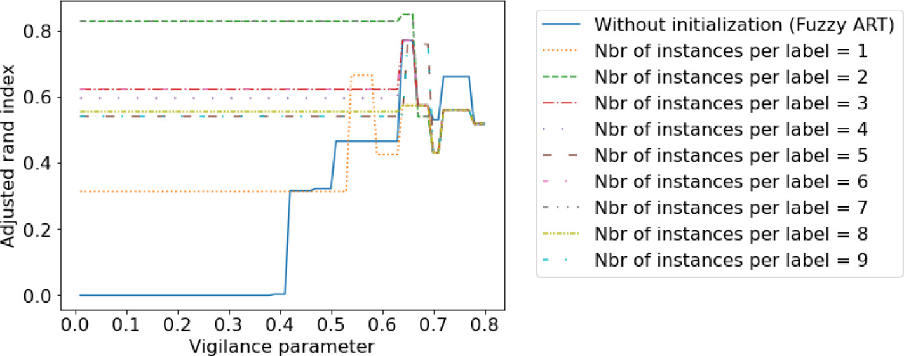

**Fig. 17.** Impact of the number of considered instances per label in the initialization sample of the SSFuzzyART compared to Fuzzy ART (without initialization). Iris dataset is

used, and three labels are considered.

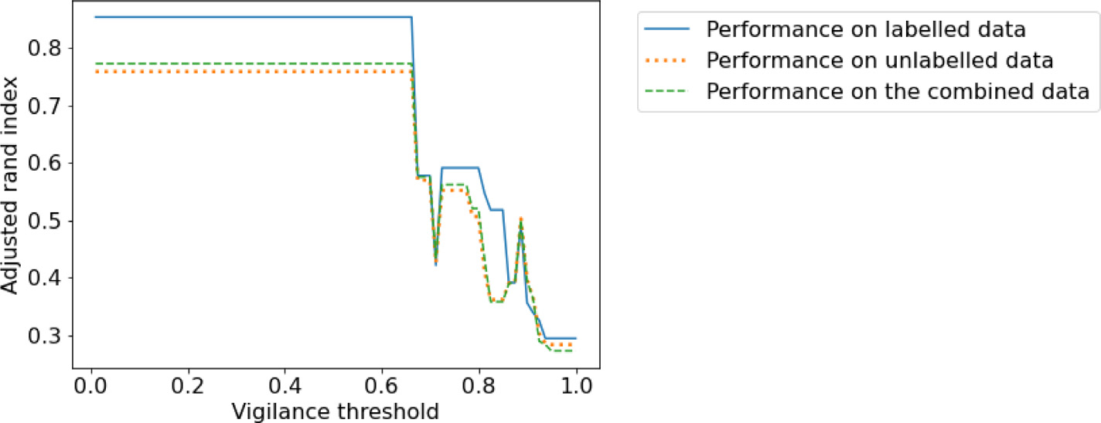

**Fig. 18.** SSFuzzyART Adjusted Rand index on the labeled data (seeds), the unlabeled data and the combined dataset. Iris dataset is used, and three labels are considered with 7

random instances per label.

According to the results in Fig. 13, Fig. 14 and Fig. 15, the SS-FuzzyART leads to better results than Fuzzy ART when the vigilance parameter, *𝜌*, values are low, and they yield similar results when *𝜌* values are higher. Indeed, when the *𝜌* parameter is high, the tolerance of the algorithm to create a new cluster is higher, which increases the number of clusters, then the initialization that is made to guide the clustering process is loosed. However, when the *𝜌* parameter is low, the tolerance to create a new cluster is low too. Then, the number of cluster is also low, and the algorithm will not be allowed to add many clusters, especially when most possible labels are represented with corresponding neurons in the *𝐿*2 layer.

Another important conclusion from these experiments is that the available number of labels in the initialization sample has an impact on the output prediction. When only one label is available in the initialization sample, the SSFuzzyART and Fuzzy ART have almost the same output results. However, when the number of available labels in the initialization sample increases, the quality of the clustering increases too. Besides, according to the results in Fig. 13 and Fig. 14, even with two available labels from three in the labeled data, the SSFuzzyART is able to improve the clustering performance compared to the classic Fuzzy ART results.

Furthermore, the classic Fuzzy ART algorithm is sensitive to data order and its results are impacted with it. Indeed, clusters are cre-ated gradually with the arriving of data instance, as explained in above. With the initialization step, the algorithm is provided with some information that helps to better detect the clusters. Consequently, SSFuzzyART improves the clustering performance thanks to this initial-ization.

A second experiment is made to study the impact of number of instances in the initialization sample if there is only one available label in the data. Nine different samples were considered, and the number of instances in these samples is in the range [1*,* 9] and all samples are

13

*S. Jendoubi et al.*  *Array 19 (2023) 100319*

**6. Conclusion**

This paper introduces a SSFuzzyART algorithm. It is a Fuzzy ART semi supervised clustering algorithm that can use a set of available labeled data to improve the clustering prediction. SSFuzzyART uses the labeled instances to initialize its categories in the *𝐿*2 layer. This initialization is useful to guide the clustering process, and it influences positively the clustering prediction. Besides, the classic Fuzzy ART algorithm is sensitive to the choice of the vigilance parameter that manage the tolerance of the algorithm to create a new cluster, this sensitivity has been inherited by SSFuzzyART. Then, it is generally recommended choosing a relatively low *𝜌* to get good performance. The *𝜌* value could depend on the number of categories that are present in the initialization data. Then, if all categories are present, a lower *𝜌* is recommended.

A set of experiments was made and discussed to deeply study the SSFuzzyART characteristics and to compare it to the classic Fuzzy ART algorithm. According to these experiments, SSFuzzyART initialization improved the clustering performance, especially with smaller *𝜌* values. Besides, the number of clusters present in the initialization sample has an important impact on the algorithm performance. Finally, the number of instances per label in the initialization sample has no impact on the clustering performance.

In the future work, it will be interesting to test SSFuzzyART in a real world problem and to study its impact on real data. A second perspective is to compare the three possible scenarios introduced in Section 3.2, and to study their impact on real world problems. A Third perspective of this work could be to find a solution to influence the Fuzzy ART clustering process with available labeled data.

**CRediT authorship contribution statement**

**Siwar Jendoubi:** Conceptualization, Methodology, Software, Data curation, Writing – original draft, Visualization, Investigation, Writing– review & editing. **Aurélien Baelde:** Software, Conceptualization, Validation, Investigation, Writing – review & editing. **Thong Tran:** Supervision.

**Declaration of competing interest**

The authors declare that they have no known competing finan-cial interests or personal relationships that could have appeared to influence the work reported in this paper.

**Data availability**

Data will be made available on request.

**References**

[1] [Carpenter GA, Grossberg S, Rosen DB. Fuzzy ART: Fast stable learning and categorization of analog patterns by an adaptive resonance system. Neural Netw 1991;4(6):759–71.](http://refhub.elsevier.com/S2590-0056(23)00044-9/sb1)

[2] [Bingwen C, Wenw](http://refhub.elsevier.com/S2590-0056(23)00044-9/sb1)ei W, Qianqing Q. Infrared target detection based on fuzzy ART neural network. In: 2010 Second international conference on computational intelligence and natural computing. IEEE; 2010, [http://dx.doi.org/10.1109/cinc. 2010.5643745](http://dx.doi.org/10.1109/cinc.2010.5643745).

[3] Ilhan S, Duru N, Adali E. Improved fuzzy art method for initializing K-means. Int J Comput Intell Syst 2010;3(3):274. <http://dx.doi.org/10.2991/ijcis.2010.3.3.3>. [4] Liew WS, Loo CK, Wermter S. Emotio[n recognition using explainable geneticall](http://dx.doi.org/10.2991/ijcis.2010.3.3.3)y optimized fuzzy ART ensembles. IEEE Access 2021;9:61513–31. [http://dx.doi.](http://dx.doi.org/10.1109/access.2021.3072120)  [org/10.1109/access.2021.3072120](http://dx.doi.org/10.1109/access.2021.3072120).

14